AI’S AKBAR PEERBHOY COLLEGE OF EDUCATION VASHI

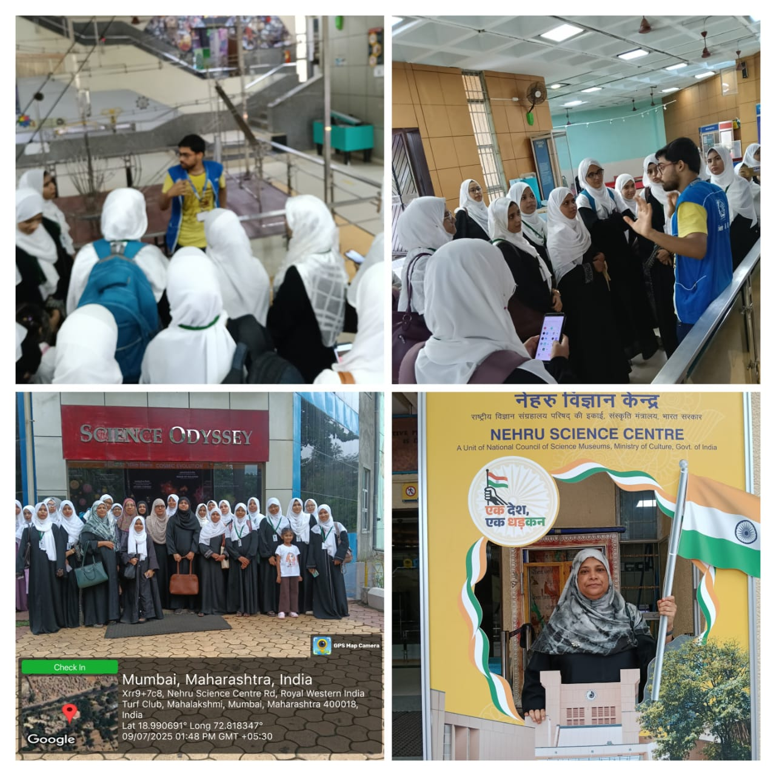

Visit to Nehru Science Centre, Mumbai
Date of Visit: 9TH JULY 2025, WEDNESDAY
Organized by: AIAPCE (Akbar Peerbhoy College of Education, Mumbai)
Purpose of Visit: To provide students with an enriching educational experience, fostering scientific curiosity and practical understanding of various scientific principles. This aligns with AIAPCE's commitment to encouraging student participation in educational and extracurricular activities.
Overview of the Nehru Science Centre: The Nehru Science Centre (NSC) in Worli, Mumbai, is India's largest interactive science center, named after India's first Prime Minister, Jawaharlal Nehru. It boasts a sprawling 8-acre Science Park and numerous permanent science expositions across various themes. The center aims to promote scientific temper and learning through hands-on exhibits, engaging shows, and educational programs.
Highlights of the Visit:
The AIAPCE students had the opportunity to explore a wide range of interactive exhibits and participate in various educational programs offered by the Nehru Science Centre. Key highlights likely included:
- Interactive Galleries: Students explored diverse galleries covering topics such as:
  - Energy
  - Sound and Hearing
  - Light and Sight
  - Kinematics and Mechanics
  - Human and Machine
  - Hall of Nuclear Power
  - Prehistoric Animal Life
  - Our Technology Heritage
  - Evolution
  - Machined to Think
- Immersive Shows: The visit likely included engaging shows designed to enhance scientific understanding:
  - Science Odyssey: A spherical projection system offering an immersive experience of scientific concepts, often including science films.
  - 3D Science Show: Documentaries and presentations with 3D viewing, providing a thrilling and educational experience.
  - Science on a Sphere: A unique display using real-time atmospheric and climatic data projected onto a spherical globe, offering a three-dimensional view of Earth and other celestial bodies.
- Science Park: Students could explore the outdoor Science Park, featuring large-scale interactive exhibits demonstrating various scientific laws and phenomena in an open-air setting.
Learning Outcomes:
The visit provided AIAPCE students with a valuable "learning by doing" experience, allowing them to:
- Gain practical understanding of scientific concepts through hands-on interaction with exhibits.
- Develop scientific curiosity and a deeper appreciation for the role of science in everyday life.
- Witness real-world applications of scientific principles.
- Enhance their observational and analytical skills.
- Engage with cutting-edge science communication tools and technologies.
Conclusion:
The visit to the Nehru Science Centre was an informative and highly engaging experience for the AIAPCE students. It successfully complemented their academic learning by providing a dynamic and interactive environment for scientific exploration, contributing significantly to their overall educational development.

